

SOFTWARE REQUIREMENT SPECIFICATION
Yu-Gi-Oh! Card Market & Deck Builder (YGO-MARKET)

– Hanoi, Nov 2026 –
Table of Contents
I. Record of Changes
II. Software Requirement Specification
1. Overall Requirements
1.1 Context Diagram
1.2 Business Workflow
1.3 User Requirements (Actors, 22 Use Cases & Use Case Diagrams)
1.4 System Functionalities (Screens Flow, Screen Authorization & Non-UI)
1.5 Entity Relationship Diagram
2. Use Case Specifications (UC-01 to UC-22)
2.1 Authentication & Profile (UC-01..UC-05)
2.2 Card Catalog, Prices & EN/VI Translation (UC-06..UC-10)
2.3 User Favorites Collection (UC-11..UC-12)
2.4 Deck Library, Personal Deck Builder & Banlist (UC-13..UC-18)
2.5 Admin Governance & CRUD Management (UC-19..UC-22)
3. Functional Requirements (UI Mockups & Field Descriptions)
4. Non-Functional Requirements
5. Requirement Appendix (Business Rules)

I. Record of Changes
Date | A* M, D | In charge | Change Description
23/10/2026 | A | Team | Initialize SRS from Yu-Gi-Oh! Card Market & Price Lookup specification.
05/11/2026 | A | Team | Add Bilingual EN/VI Card Effect Translation and MongoDB desc_vi caching.
10/11/2026 | A | Team | Add Deck Library, Personal Deck Builder, .ydk Export, Banlist History, and User Favorites.
13/11/2026 | M | Team | Finalize 22 Use Case Specifications, per-actor UC Diagrams, Workflow Diagrams, and UI Mockups in English.

*A - Added M - Modified D - Deleted

II. Software Requirement Specification

1. Overall Requirements

1.1 Context Diagram
The Yu-Gi-Oh! Card Market & Deck Builder system is a web platform for looking up current Meta Yu-Gi-Oh! cards (252+ cards), comparing prices across five international marketplaces, translating card effects between English and Vietnamese, exploring 40+ curated decks, building personal decks, exporting .ydk files, checking official Banlists, and governing catalog and user data through an Admin Dashboard. The web server reads exclusively from its own internal database (MongoDB) and local image cache without invoking external APIs per user request.
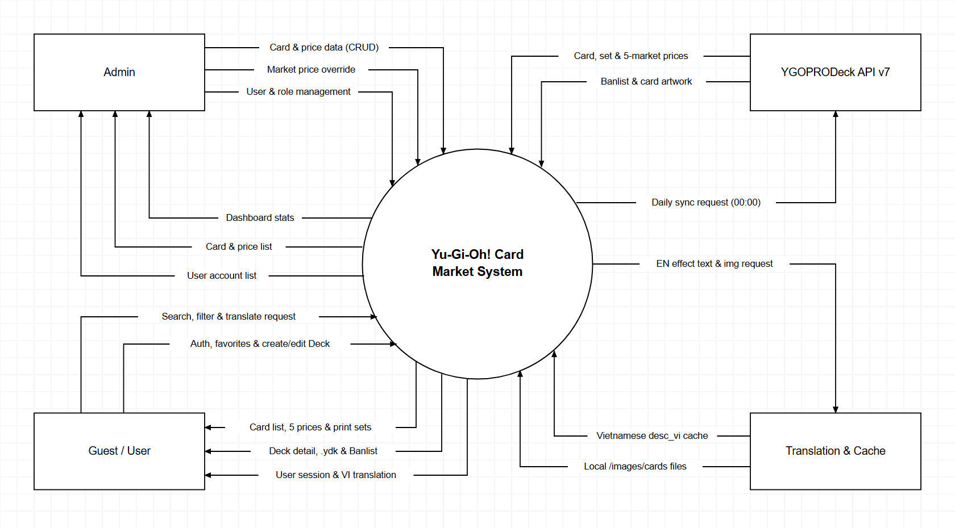
Figure 1.1: System Context Diagram

1.2 Business Workflow

1.2.1 Card Data Sync & Local Caching
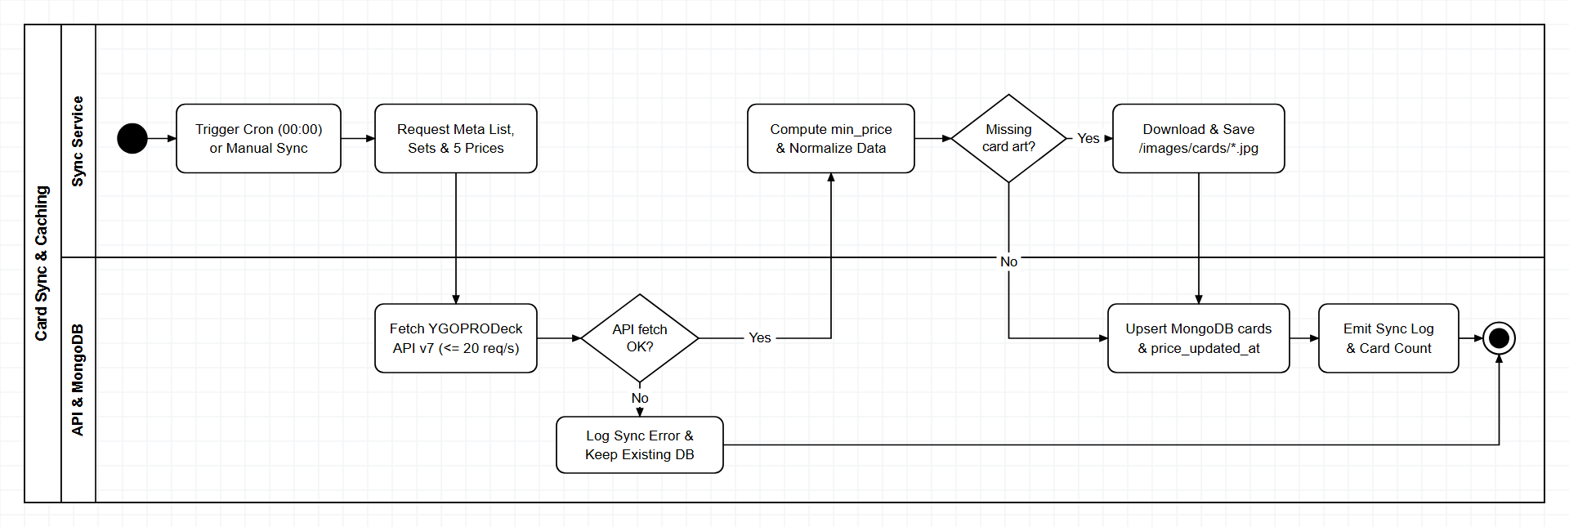
Figure 1.2.1: Daily Sync & Local Image Cache Workflow

1.2.2 Card Search, Filter & 5-Market Price Lookup
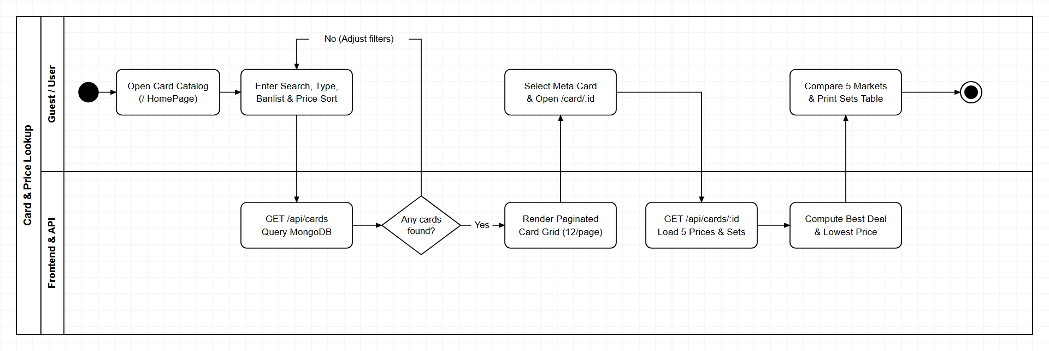
Figure 1.2.2: Card Lookup & Price Comparison Workflow

1.2.3 Bilingual Card Effect Translation (EN/VI)
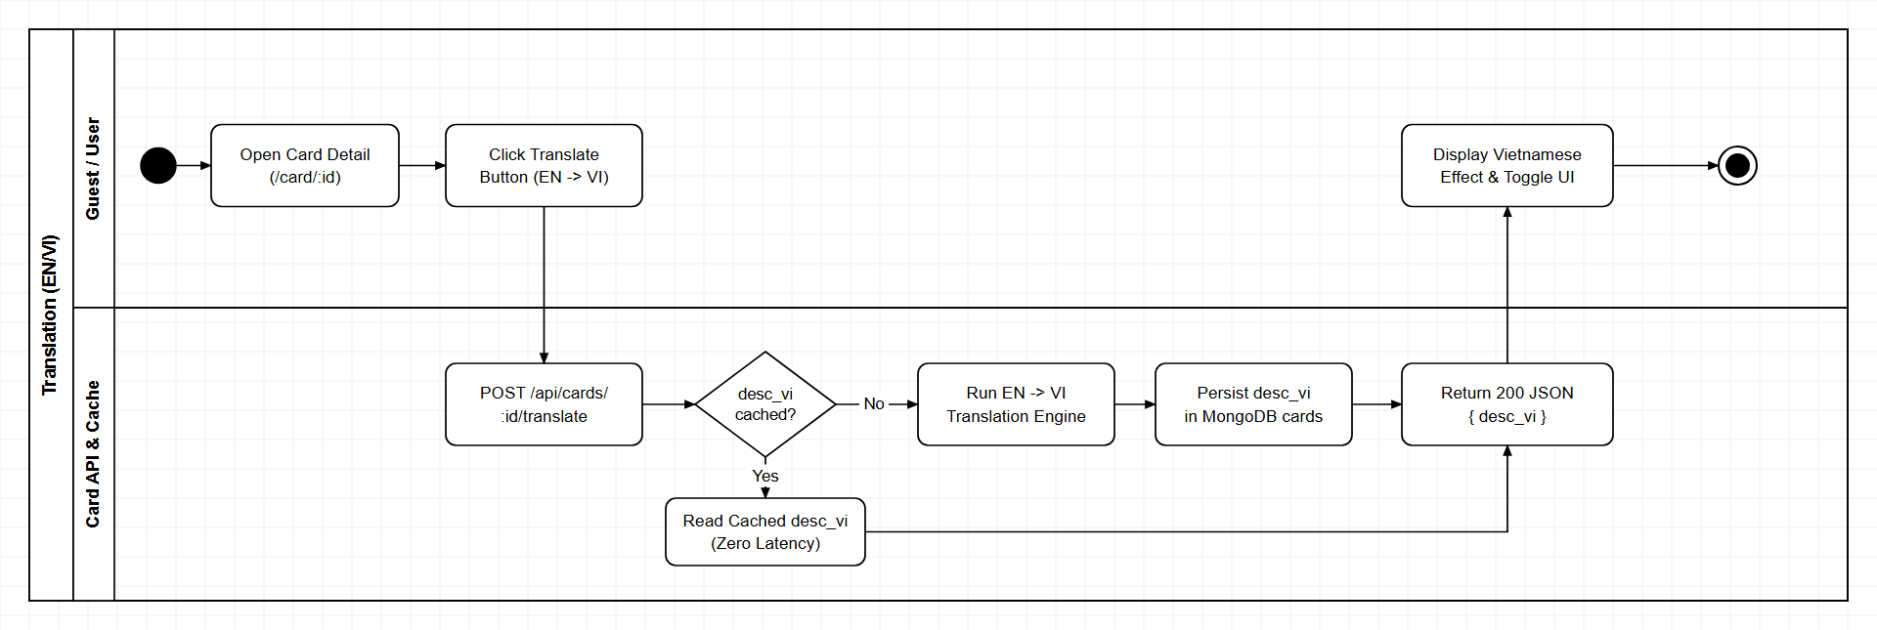
Figure 1.2.3: Bilingual EN/VI Translation & Cache Workflow

1.2.4 Deck Library, Personal Deck Builder & .ydk Export
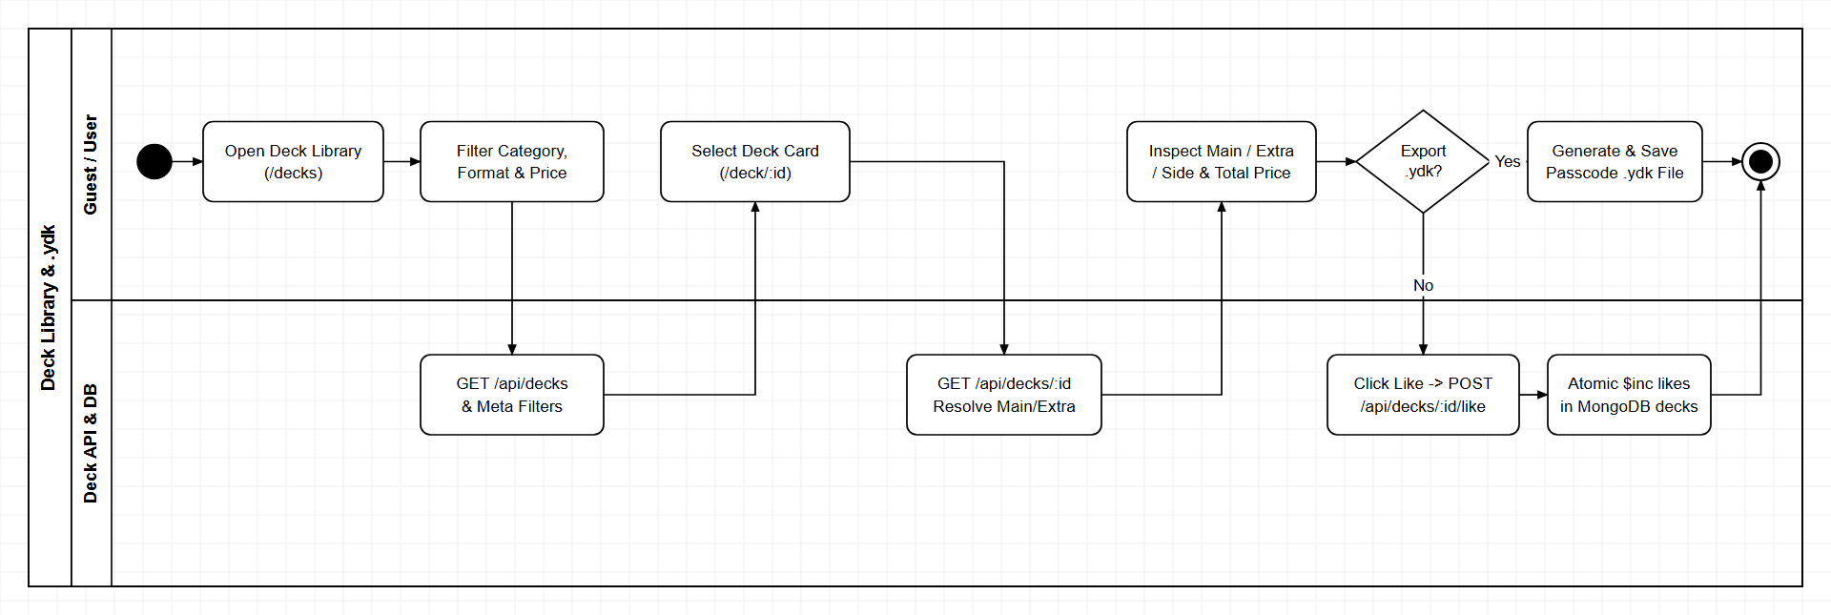
Figure 1.2.4: Deck Library, Deck Builder & .ydk Export Workflow

1.2.5 User Authentication & Favorites
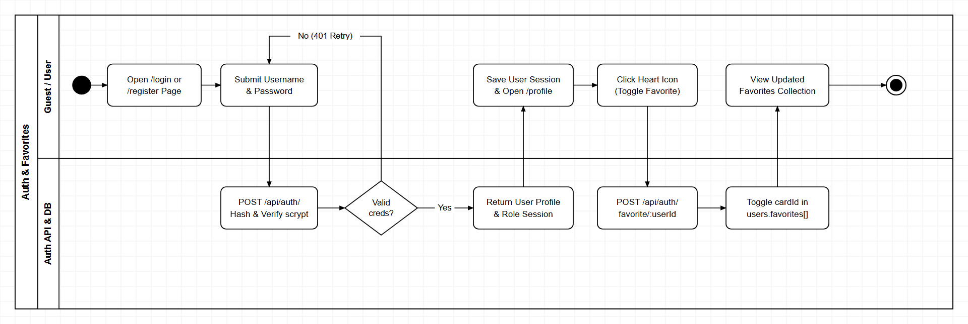
Figure 1.2.5: Authentication & Personal Collection Workflow

1.2.6 Admin Governance (Cards, Prices & Users)
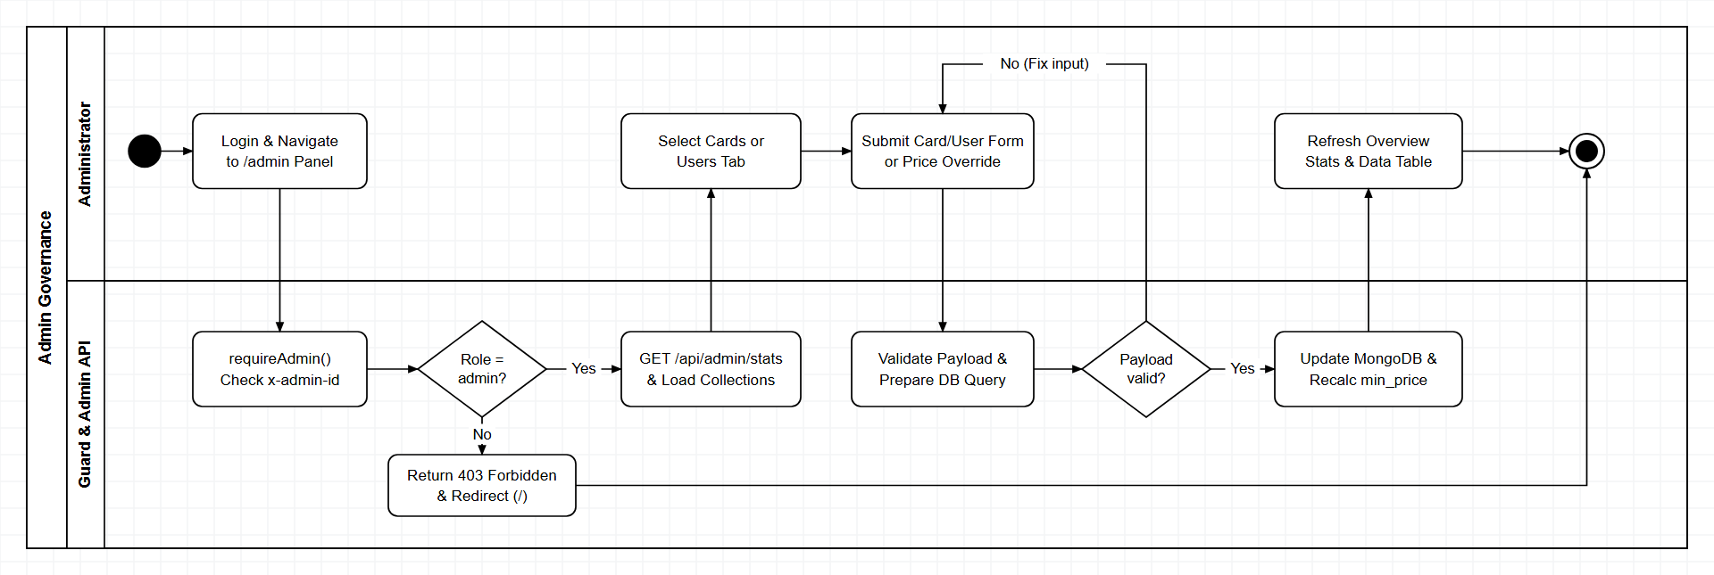
Figure 1.2.6: Admin Governance & CRUD Workflow

1.3 User Requirements

1.3.1 Actors
# | Actor | Description
1 | Guest | Unauthenticated player or collector who can browse/filter Meta cards, compare 5-market prices, translate card effects (EN/VI), inspect decks, export .ydk files, and view Banlists.
2 | Registered User | Authenticated member with an active session stored in localStorage who retains all Guest capabilities plus managing personal profile, changing password, maintaining a Favorite Cards collection, and creating/editing personal decks via Deck Builder.
3 | Administrator | System administrator (role='admin', verified via x-admin-id header and database role lookup) authorized to access the Admin Dashboard, view overview statistics, perform CRUD on Cards, override market prices, and manage User accounts and roles.

1.3.2 Use Cases (UC)
ID | Use Case | Feature | Primary Actor | Use Case Description
UC-01 | Register Account | Auth | Guest | Create a new member account with unique username and scrypt-hashed password.
UC-02 | Login to System | Auth | All Actors | Authenticate credentials via scrypt and establish a user session in localStorage.
UC-03 | Logout | Auth | User / Admin | Terminate current authenticated session and clear user state from localStorage.
UC-04 | View Personal Profile | Profile | User / Admin | Display user account metadata, saved Favorite Cards, and total collection value.
UC-05 | Change Password | Profile | User / Admin | Verify existing password and persist a new scrypt password hash.
UC-06 | Browse & Paginate Meta Cards | Card Catalog | Guest / User | Browse the grid of 252+ current Meta cards (12 cards/page) with lowest price indicator and pagination.
UC-07 | Search, Filter & Sort Cards | Card Catalog | Guest / User | Search by card name (fname), filter by Type/Attribute/Race/Level/Archetype/Banlist, and sort.
UC-08 | View Card Detail & 5-Market Prices | Card Detail | Guest / User | Inspect full card stats, local high-res artwork, and prices across 5 markets.
UC-09 | View Print Set Prices & Rarity | Card Detail | Guest / User | Inspect the table of card sets, set codes, rarities, and set prices.
UC-10 | Translate Card Effect (EN/VI) | Translation | Guest / User | Translate English card effect text into Vietnamese and persist desc_vi in DB.
UC-11 | Add / Remove Favorite Card | Collection | Registered User | Toggle a card inside the user's personal favorites list.
UC-12 | View Favorite Cards Collection | Collection | Registered User | View all bookmarked favorite cards and total collection value on the Profile page.
UC-13 | Browse & Filter Deck Library | Deck Library | Guest / User | Search and filter 40+ decks by Category, Format, Archetype, and price range.
UC-14 | View Deck Detail & Stats | Deck Detail | Guest / User | View Main, Extra, and Side Deck card counts, Banlist badges, and estimated cost.
UC-15 | Like Deck | Deck Detail | Guest / User | Increment the engagement like counter on a selected deck.
UC-16 | Export Deck to .ydk | Deck Detail | Guest / User | Download a standard #main/#extra/!side .ydk file compatible with YGOPro/EDOPro.
UC-17 | View Official Banlist History | Banlist | Guest / User | Browse Forbidden, Limited, and Semi-Limited cards across TCG, OCG, and Master Duel formats.
UC-18 | Create & Manage Personal Decks | Deck Builder | Registered User | Create, edit, or delete personal decks in Main, Extra, and Side Deck sections.
UC-19 | View Admin Overview Stats | Admin Dashboard | Administrator | Inspect aggregate counts for Meta Cards, Decks, and Registered Users.
UC-20 | Manage Cards (CRUD) | Admin Cards | Administrator | Create, update, or delete card documents in MongoDB.
UC-21 | Override Card Market Price | Admin Cards | Administrator | Manually adjust 5-market prices and recompute min_price and price_updated_at.
UC-22 | Manage Users & Roles | Admin Users | Administrator | View registered accounts, toggle roles ('user'/'admin'), or delete accounts.

1.3.3 Use Case Diagrams

1.3.3.1 UCs for Guest
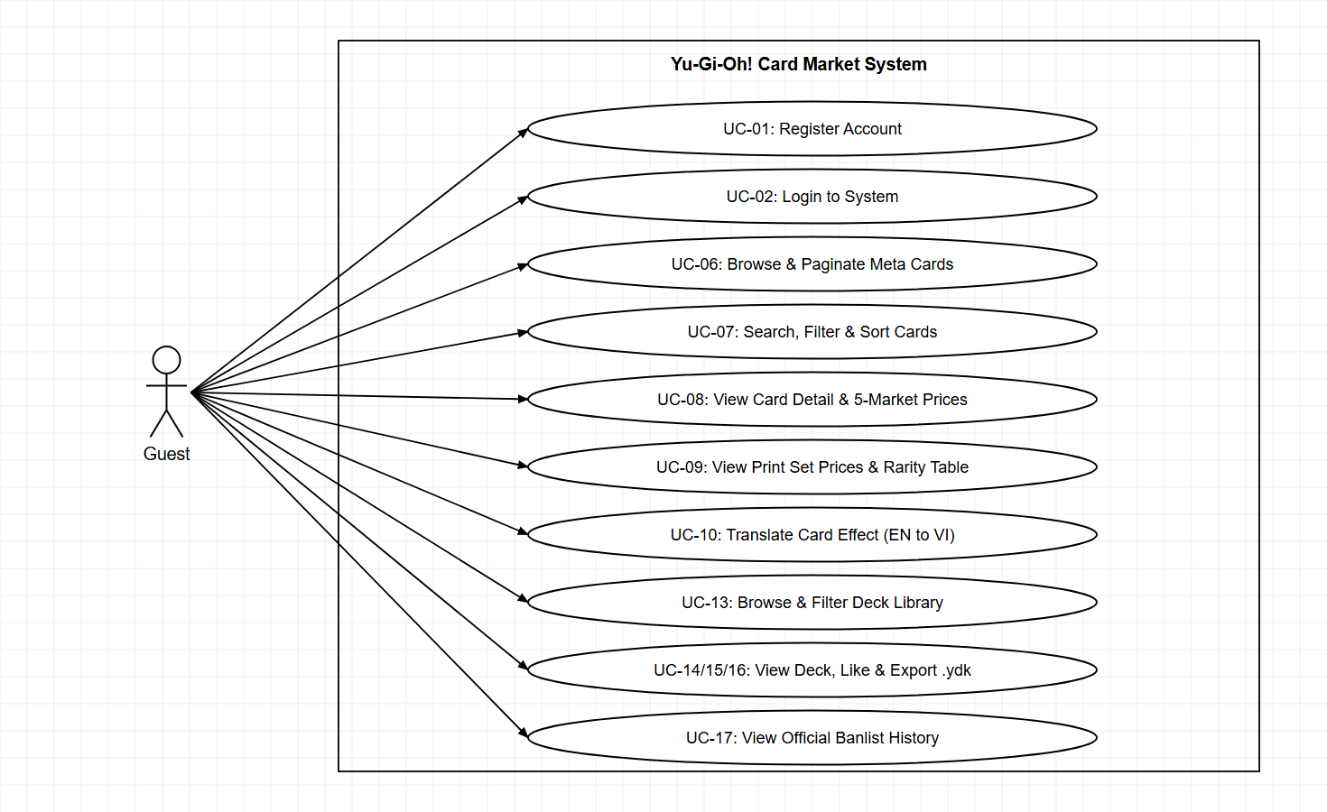
Figure 1.3.1: Use Case Diagram - Guest

1.3.3.2 UCs for Registered User
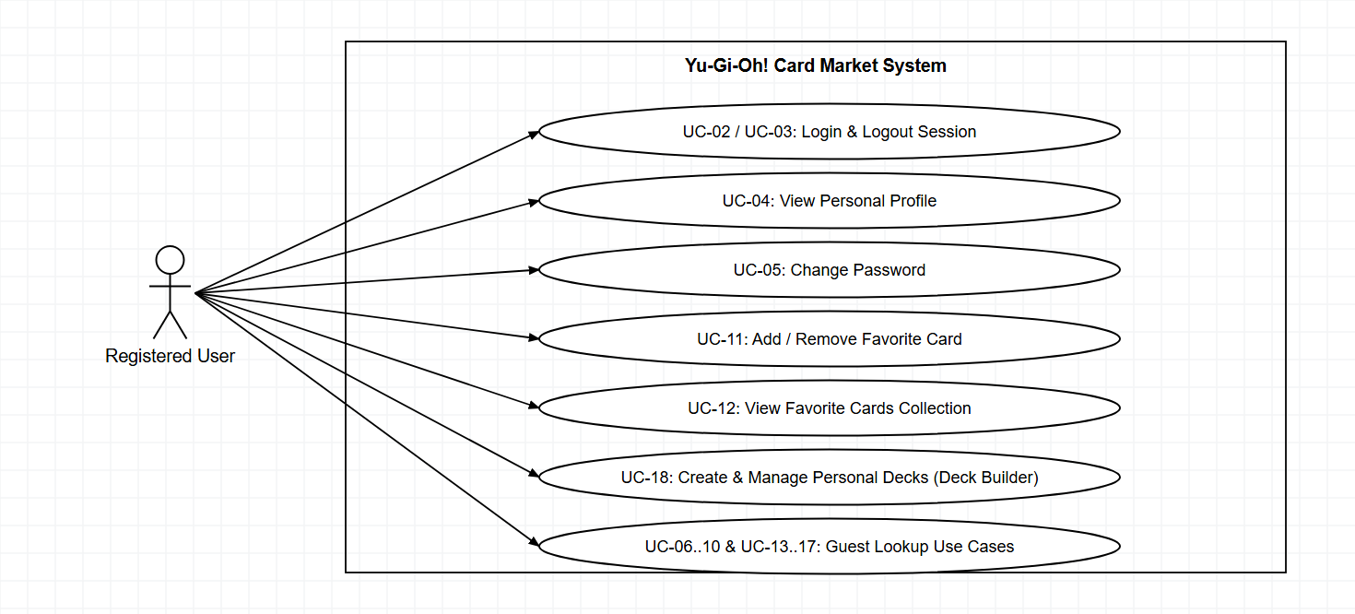
Figure 1.3.2: Use Case Diagram - Registered User

1.3.3.3 UCs for Administrator
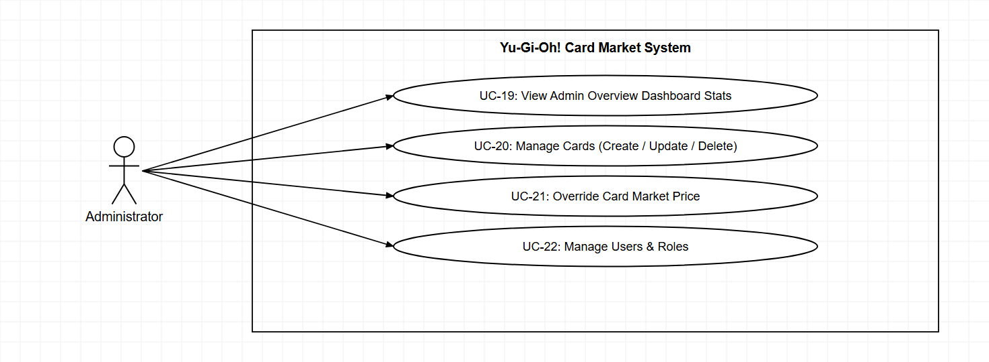
Figure 1.3.3: Use Case Diagram - Administrator

1.4 System Functionalities

1.4.1 Screens Flow

1.4.1.1 Guest & Registered User Flow
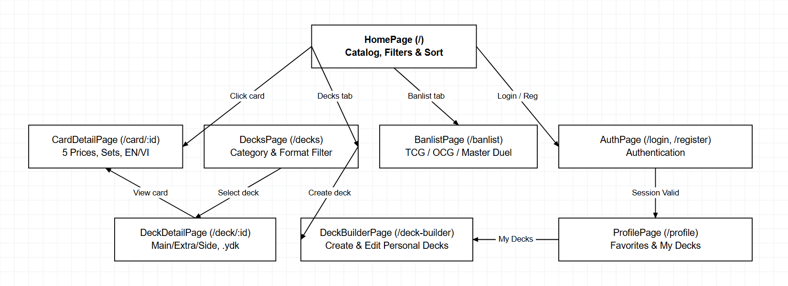
Figure 1.4.1: Screens Flow - Guest & Registered User

1.4.1.2 Administrator Flow
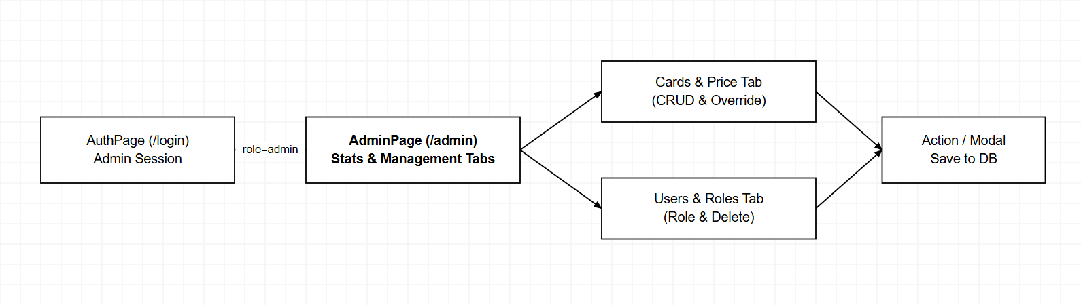
Figure 1.4.2: Screens Flow - Administrator

1.4.2 Screen Authorization
Screen / Modal | Guest | Registered User | Admin
HomePage (/) – Catalog, Search, Filter & Sort | X | X | X
CardDetailPage (/card/:id) – 5 Prices, Print Sets, Translate | X | X | X
Toggle Favorite Button (on CardDetailPage) | - | X | X
DecksPage (/decks) – Library & Filters | X | X | X
DeckDetailPage (/deck/:id) – View, Like & Export .ydk | X | X | X
DeckBuilderPage (/deck-builder) – Create & Edit Personal Decks | - | X | X
BanlistPage (/banlist) – TCG / OCG / Master Duel | X | X | X
AuthPage (/login, /register) | X | - | -
ProfilePage (/profile) – Favorites, My Decks & Change Password | - | X | X
AdminPage (/admin) – Overview, Cards, Price Override & Users | - | - | X

1.4.3 Non-UI Functions
# | Feature | System Function | Description
1 | Data Sync | Daily Price Sync Cron Job | Scheduled at 00:00 daily via node-cron to refresh card_prices and min_price in MongoDB.
2 | Image Storage | Static Proxy (/images/cards) | Serves cached local card images from be/public/images/cards without external hotlinking.
3 | Security | scrypt, requireAuth & requireAdmin | Hashes passwords as salt:hash via crypto.scryptSync; protects user deck routes with requireAuth (x-user-id) and /api/admin/* with requireAdmin.
4 | Translation | MongoDB desc_vi Cache | Persists translated Vietnamese card effects into desc_vi for instant subsequent retrieval.

1.5 Entity Relationship Diagram
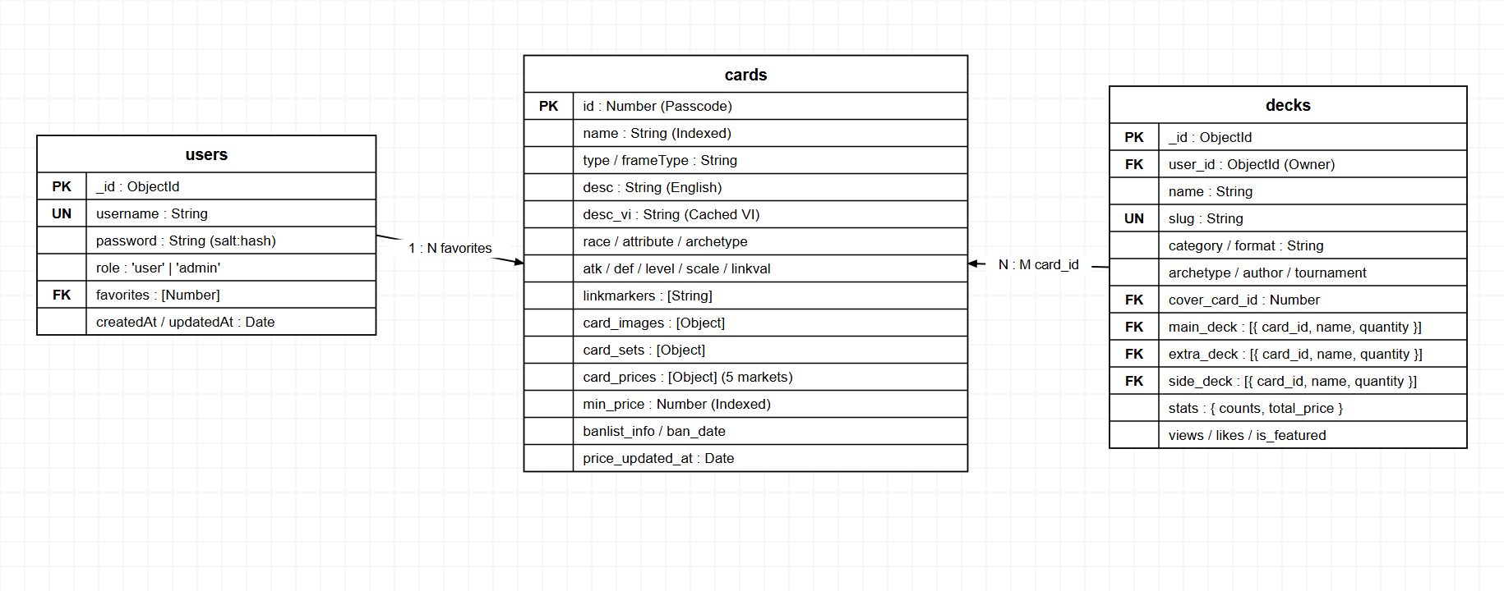
Figure 1.5: Entity Relationship Diagram (MongoDB yugioh_db)
# | Entity / Embedded Doc | Description
1 | users | User accounts storing unique username, scrypt password hash, role ('user'/'admin'), and favorites array of Card.id.
2 | cards | Meta card master records containing Passcode id, name, type, frameType, desc, desc_vi, combat stats, min_price, and ban_date.
3 | card_images / card_sets / card_prices | Embedded sub-documents storing card artwork URLs, print set rarities/prices, and 5-market retail pricing.
4 | decks | Deck records with name, slug, user_id (owner reference), category, format, archetype, main_deck/extra_deck/side_deck card lists, stats, views, and likes.

2. Use Case Specifications

2.1 Authentication & Profile

2.1.1 UC-01 – Register Account
Primary Actors | Guest | Secondary Actors | None
Description | Allows an unauthenticated visitor to create a new member account.
Preconditions | The user is not logged in and has navigated to /register.
Postconditions | A new User document is stored in the users collection with role='user' and a scrypt password hash; the client stores the user session in localStorage.
Normal Sequence/Flow | 1. Guest navigates to /register.  2. User enters a unique username and password (min 6 characters).  3. User submits the form -> Frontend sends POST /api/auth/register.  4. Backend validates uniqueness, hashes password with crypto.scryptSync, and saves User.  5. System returns HTTP 201 + user profile data and redirects to /.
Alternative Sequences/Flows | Alt 1 (Duplicate username): Backend returns HTTP 400 and displays 'Username already exists'.  Alt 2 (Validation error): Form blocks submission if password < 6 characters.

2.1.2 UC-02 – Login to System
Primary Actors | Guest / User / Admin | Secondary Actors | None
Description | Authenticates existing credentials via scrypt timingSafeEqual and establishes a client session.
Preconditions | A registered account exists in MongoDB.
Postconditions | User profile and role are persisted in localStorage; Navbar updates to display Profile (and Admin link if role='admin').
Normal Sequence/Flow | 1. User navigates to /login.  2. User inputs username and password.  3. Frontend sends POST /api/auth/login.  4. Backend verifies the scrypt password hash using crypto.timingSafeEqual.  5. Backend returns HTTP 200 { id, username, role, createdAt, favorites } and Frontend redirects home.
Alternative Sequences/Flows | Alt 1 (Invalid credentials): Backend returns HTTP 401 'Invalid username or password'.

2.1.3 UC-03 – Logout
Primary Actors | Registered User / Admin | Secondary Actors | None
Description | Ends the currently authenticated user session.
Preconditions | The user is currently logged in.
Postconditions | The user session state is cleared from browser localStorage, reverting access to Guest level.
Normal Sequence/Flow | 1. User clicks Logout on the Navbar.  2. System removes user object from localStorage and resets AuthContext.  3. System redirects to /login or /.
Alternative Sequences/Flows | None.

2.1.4 UC-04 – View Personal Profile
Primary Actors | Registered User / Admin | Secondary Actors | None
Description | Displays account details, total collection value, and the user's saved favorite cards collection.
Preconditions | The user is logged in with a valid userId in AuthContext.
Postconditions | ProfilePage displays username, role, collection stats, and all populated favorite cards.
Normal Sequence/Flow | 1. User clicks Profile in Navbar (/profile).  2. Frontend requests GET /api/auth/profile/:userId.  3. Backend queries User (excluding password), resolves cards in favorites[], and computes totalCollectionValue.  4. Frontend renders account info and collection grid.
Alternative Sequences/Flows | Alt 1 (Unauthenticated session): System redirects to /login.

2.1.5 UC-05 – Change Password
Primary Actors | Registered User / Admin | Secondary Actors | None
Description | Allows an authenticated user to update their account password.
Preconditions | User is logged in and viewing /profile.
Postconditions | The new password is hashed with crypto.scrypt and saved to the users collection.
Normal Sequence/Flow | 1. On /profile, user enters Current Password and New Password.  2. User submits -> Frontend sends PUT /api/auth/change-password/:userId.  3. Backend verifies the current password hash, hashes the new password, and updates DB.  4. UI displays a confirmation banner.
Alternative Sequences/Flows | Alt 1 (Incorrect current password): Backend returns HTTP 400 and rejects update.

2.2 Card Catalog, Prices & Translation

2.2.1 UC-06 – Browse & Paginate Meta Cards
Primary Actors | Guest / User | Secondary Actors | None
Description | Browses the paginated grid of 252+ current Meta cards with local artwork and minimum price.
Preconditions | The cards collection in MongoDB is populated.
Postconditions | CardGrid renders the requested page of Meta cards along with min_price.
Normal Sequence/Flow | 1. User opens HomePage (/).  2. Frontend sends GET /api/cards?page=1&limit=...  3. Backend queries MongoDB and returns paginated cards and total count.  4. User clicks page numbers on Pagination to navigate.
Alternative Sequences/Flows | Alt 1 (Database connection error): System returns HTTP 500 with error state.

2.2.2 UC-07 – Search, Filter & Sort Cards
Primary Actors | Guest / User | Secondary Actors | None
Description | Performs fuzzy name search, multi-attribute filtering, and sorting on the card catalog.
Preconditions | User is on HomePage (/).
Postconditions | CardGrid updates to show cards matching all active filter criteria in the requested sort order.
Normal Sequence/Flow | 1. User types a card name in SearchBar or selects Type, Attribute, Race, Level (LevelFilter), Archetype, or Banlist.  2. User selects Sort order (Name, min_price, ATK, DEF, Level).  3. Frontend sends GET /api/cards with query parameters.  4. Backend filters and sorts via MongoDB and returns updated list.
Alternative Sequences/Flows | Alt 1 (No matching cards): UI shows an empty state with a 'Reset Filters' action.

2.2.3 UC-08 – View Card Detail & 5-Market Prices
Primary Actors | Guest / User | Secondary Actors | None
Description | Displays complete card attributes, local artwork, and prices across 5 retail markets.
Preconditions | A valid card ID exists in MongoDB.
Postconditions | CardDetailPage (/card/:id) displays full specs and the 5-market price comparison bar.
Normal Sequence/Flow | 1. User clicks a card thumbnail from CardGrid or DeckDetailPage.  2. Router opens /card/:id and calls GET /api/cards/:id.  3. UI renders ATK/DEF/Level/Link/Scale, English effect, and prices from Cardmarket (EUR), TCGplayer (USD), eBay (USD), Amazon (USD), CoolStuffInc (USD) plus price_updated_at.
Alternative Sequences/Flows | Alt 1 (Card ID not found): Backend returns HTTP 404 'Card not found'.

2.2.4 UC-09 – View Print Set Prices & Rarity Table
Primary Actors | Guest / User | Secondary Actors | None
Description | Displays all physical print editions of a card with set codes, rarities, and set prices.
Preconditions | User is viewing CardDetailPage and the card has card_sets entries.
Postconditions | Print Sets table renders Set Name, Set Code, Rarity, and Set Price ($).
Normal Sequence/Flow | 1. User scrolls to the Print Sets section on /card/:id.  2. System renders rows from card.card_sets.  3. User compares rarities (Common, Super, Ultra, Secret Rare) and pricing.
Alternative Sequences/Flows | Alt 1 (No print sets available): Displays 'No set release data available'.

2.2.5 UC-10 – Translate Card Effect (EN to VI)
Primary Actors | Guest / User | Secondary Actors | Translation Pipeline
Description | Translates a card's English effect text into Vietnamese on demand and caches the result.
Preconditions | User is viewing CardDetailPage and the card has desc text.
Postconditions | Vietnamese translation is displayed in the UI and cached in card.desc_vi in MongoDB.
Normal Sequence/Flow | 1. User clicks the Translate button on CardDetailPage.  2. Frontend sends GET/POST /api/cards/:id/translate.  3. If card.desc_vi already exists -> return cached text immediately.  4. Otherwise run EN->VI translation pipeline, store desc_vi in MongoDB, and return JSON.  5. UI displays translated text alongside English original.
Alternative Sequences/Flows | Alt 1 (Translation service error): Displays a friendly retry message without crashing the page.

2.3 User Collection (Favorites)

2.3.1 UC-11 – Add / Remove Favorite Card
Primary Actors | Registered User | Secondary Actors | None
Description | Adds or removes a card from the logged-in user's personal favorites collection.
Preconditions | User is authenticated with an active session.
Postconditions | The cardId is added to or removed from user.favorites in MongoDB.
Normal Sequence/Flow | 1. User clicks the Favorite (Star/Heart) button on CardDetailPage or ProfilePage.  2. Frontend sends POST /api/auth/favorite/:userId with { cardId }.  3. Backend toggles cardId in user.favorites and saves.  4. UI updates button state and localStorage.
Alternative Sequences/Flows | Alt 1 (Unauthenticated user): Prompts user to log in.

2.3.2 UC-12 – View Favorite Cards Collection
Primary Actors | Registered User | Secondary Actors | None
Description | Displays all bookmarked cards inside the user's Profile page.
Preconditions | User is authenticated and has navigated to /profile.
Postconditions | Grid of favorite cards with lowest prices renders on ProfilePage.
Normal Sequence/Flow | 1. User opens /profile.  2. Backend returns populated Card records matching user.favorites.  3. User can click any card to view details or remove it.
Alternative Sequences/Flows | Alt 1 (Empty collection): Displays prompt inviting the user to browse HomePage.

2.4 Deck Library, Personal Deck Builder & Banlist

2.4.1 UC-13 – Browse & Filter Deck Library
Primary Actors | Guest / User | Secondary Actors | None
Description | Browses 40+ decks and filters by Category, Format, Archetype, and price range.
Preconditions | The decks collection in MongoDB is populated.
Postconditions | DecksPage displays matching deck cards with cover art, card counts, and estimated total price.
Normal Sequence/Flow | 1. User opens /decks.  2. Frontend fetches GET /api/decks/meta and GET /api/decks.  3. User filters by Category (Tournament Meta, Top Archetype, Budget Deck, Community Deck...), Format (TCG, OCG, Master Duel, GOAT, Edison), or keyword.  4. Filtered list updates.
Alternative Sequences/Flows | Alt 1 (No decks match filters): Displays empty search state.

2.4.2 UC-14 – View Deck Detail & Stats
Primary Actors | Guest / User | Secondary Actors | None
Description | Inspects Main Deck, Extra Deck, and Side Deck composition with Banlist badges and cost.
Preconditions | A valid deck ID or slug exists in MongoDB.
Postconditions | DeckDetailPage displays Monster/Spell/Trap grouping, copy badges (1x-3x), and total estimated value.
Normal Sequence/Flow | 1. User clicks a Deck on DecksPage -> opens /deck/:id.  2. Frontend requests GET /api/decks/:id.  3. Backend resolves card details & prices for Main/Extra/Side sections.  4. UI renders sections and aggregate statistics (plus Edit button if logged-in user owns the deck).
Alternative Sequences/Flows | Alt 1 (Deck not found): Returns HTTP 404.

2.4.3 UC-15 – Like Deck
Primary Actors | Guest / User | Secondary Actors | None
Description | Increments the like count for a deck in the library.
Preconditions | User is viewing DeckDetailPage (/deck/:id).
Postconditions | Deck likes count increases by 1 in MongoDB.
Normal Sequence/Flow | 1. User clicks the Like button on DeckDetailPage.  2. Frontend sends POST /api/decks/:id/like.  3. Backend executes $inc { likes: 1 } and returns updated count.
Alternative Sequences/Flows | None.

2.4.4 UC-16 – Export Deck to .ydk
Primary Actors | Guest / User | Secondary Actors | None
Description | Exports the complete deck list as a standard .ydk file for simulator import.
Preconditions | User is viewing DeckDetailPage (/deck/:id) or DeckBuilderPage (/deck-builder).
Postconditions | Browser downloads <deck-slug>.ydk formatted with #main, #extra, and !side Passcodes.
Normal Sequence/Flow | 1. User clicks 'Export .ydk' on DeckDetailPage or DeckBuilderPage.  2. Client expands each deck entry by copy count into Konami Passcode IDs.  3. Browser generates a text Blob and triggers file download.
Alternative Sequences/Flows | None.

2.4.5 UC-17 – View Official Banlist History
Primary Actors | Guest / User | Secondary Actors | None
Description | Displays Forbidden, Limited, and Semi-Limited cards organized by official format, year, and effective month.
Preconditions | Cards collection and ygoprodeck_all_banlists.json contain Banlist metadata.
Postconditions | BanlistPage displays cards grouped by Banlist tier and selected year/month dropdowns.
Normal Sequence/Flow | 1. User navigates to /banlist.  2. Frontend calls GET /api/cards/sample/banned.  3. User switches between TCG, OCG, and Master Duel tabs, selects Year and Month from dropdown selectors, and filters by restriction tier.
Alternative Sequences/Flows | Alt 1 (No banned cards in selected filter): Displays empty state message.

2.4.6 UC-18 – Create & Manage Personal Decks (Deck Builder)
Primary Actors | Registered User | Secondary Actors | None
Description | Allows a logged-in user to build, edit, or delete personal Yu-Gi-Oh! decks (Main 40-60, Extra <=15, Side <=15).
Preconditions | User is authenticated with an active session (verified via requireAuth and x-user-id header).
Postconditions | Personal Deck document with user_id reference, computed card counts, and total_price is saved or updated in MongoDB.
Normal Sequence/Flow | 1. User opens /deck-builder (from Navbar, DecksPage, or ProfilePage).  2. Frontend fetches user's saved decks via GET /api/decks/my-decks.  3. User searches cards, adds 1-3 copies to Main/Extra/Side Deck, and fills deck name/format/archetype.  4. User clicks Save -> Frontend sends POST /api/decks (or PUT /api/decks/:id) with x-user-id header.  5. Backend validates ownership and card counts, computes stats, and persists Deck.
Alternative Sequences/Flows | Alt 1 (Missing deck name or empty Main Deck): Returns HTTP 400 validation error.  Alt 2 (Unauthorized edit/delete of another user's deck): Backend returns HTTP 403 Forbidden.

2.5 Admin Governance & CRUD

2.5.1 UC-19 – View Admin Overview Stats
Primary Actors | Administrator | Secondary Actors | None
Description | Displays system-wide metrics for Meta Cards, Decks, and Registered Users.
Preconditions | User is authenticated with role='admin' (verified via x-admin-id header).
Postconditions | AdminPage dashboard cards display current document counts and charts.
Normal Sequence/Flow | 1. Admin opens /admin.  2. Frontend calls GET /api/admin/stats with x-admin-id header.  3. Middleware requireAdmin queries User by ID and validates user.role === 'admin'.  4. Backend returns counts and renders dashboard summary.
Alternative Sequences/Flows | Alt 1 (Unauthorized / Non-Admin): Middleware returns HTTP 401/403 Forbidden.

2.5.2 UC-20 – Manage Cards (Create / Update / Delete)
Primary Actors | Administrator | Secondary Actors | None
Description | Allows the Admin to add new cards, edit card attributes/descriptions, or delete cards.
Preconditions | Admin has opened the Cards tab on /admin.
Postconditions | Cards collection reflects created, updated, or deleted records.
Normal Sequence/Flow | 1. Admin loads table via GET /api/admin/cards.  2. Admin triggers Create, Edit, or Delete -> sends POST / PUT / DELETE to /api/admin/cards(/:id).  3. Backend validates payload and updates MongoDB.
Alternative Sequences/Flows | Alt 1 (Duplicate Passcode ID on create): Backend returns HTTP 400 validation error.

2.5.3 UC-21 – Override Card Market Price
Primary Actors | Administrator | Secondary Actors | None
Description | Allows the Admin to manually adjust 5-market prices for a card and recompute min_price.
Preconditions | Admin selects a card for price editing on /admin.
Postconditions | card_prices, min_price, and price_updated_at are recalculated and persisted.
Normal Sequence/Flow | 1. Admin edits marketplace prices in the Price Override modal.  2. Frontend sends PUT /api/admin/cards/:id/price.  3. Backend recalculates the lowest non-zero price as min_price and sets price_updated_at to current timestamp.
Alternative Sequences/Flows | Alt 1 (Negative price input): Backend returns HTTP 400 validation error.

2.5.4 UC-22 – Manage Users & Roles
Primary Actors | Administrator | Secondary Actors | None
Description | Allows the Admin to inspect user accounts, promote/demote roles, or delete accounts.
Preconditions | Admin is on the Users tab of /admin.
Postconditions | Target user's role ('user'/'admin') is updated or user document is deleted.
Normal Sequence/Flow | 1. Admin fetches users via GET /api/admin/users.  2. Admin toggles role via PUT /api/admin/users/:id/role or deletes via DELETE /api/admin/users/:id.  3. Admin table refreshes.
Alternative Sequences/Flows | Alt 1 (User not found): Returns HTTP 404.

3. Functional Requirements

3.1 Card Catalog Screen (HomePage)
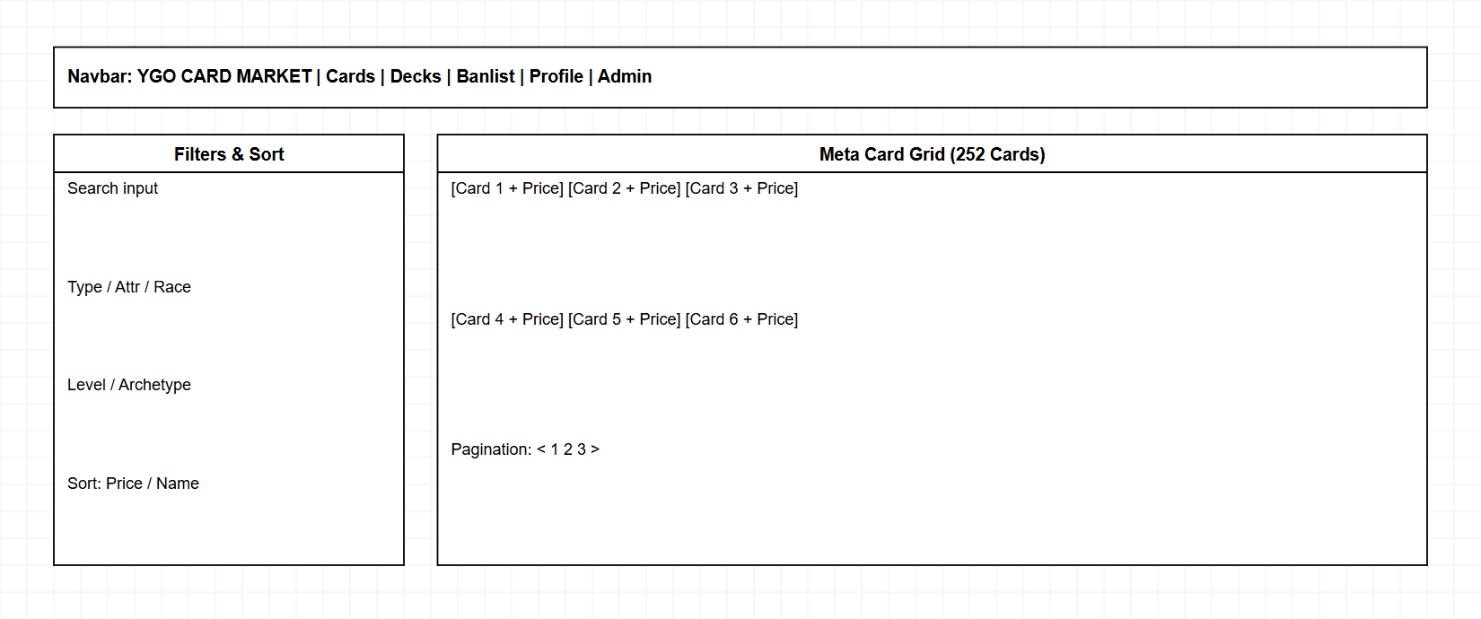
Figure 3.1: HomePage UI Wireframe
Field Name | Description
Search Bar | Text input searching cards by name via GET /api/cards?fname=...
Filter Dropdowns | Multi-criteria filters for Type, Attribute, Race, Archetype, Banlist (TCG/OCG), and Level/Rank/Link (1-12).
Sort Selector | Sorts card grid by Name, Lowest Price (min_price), ATK, DEF, or Level.
CardGrid & CardItem | Responsive card grid (12 cards/page) rendering locally cached artwork (/images/cards), name, and min_price.
Pagination | Page navigation controls (Previous / Page Numbers / Next).

3.2 Card Detail & Bilingual Translation (CardDetailPage)
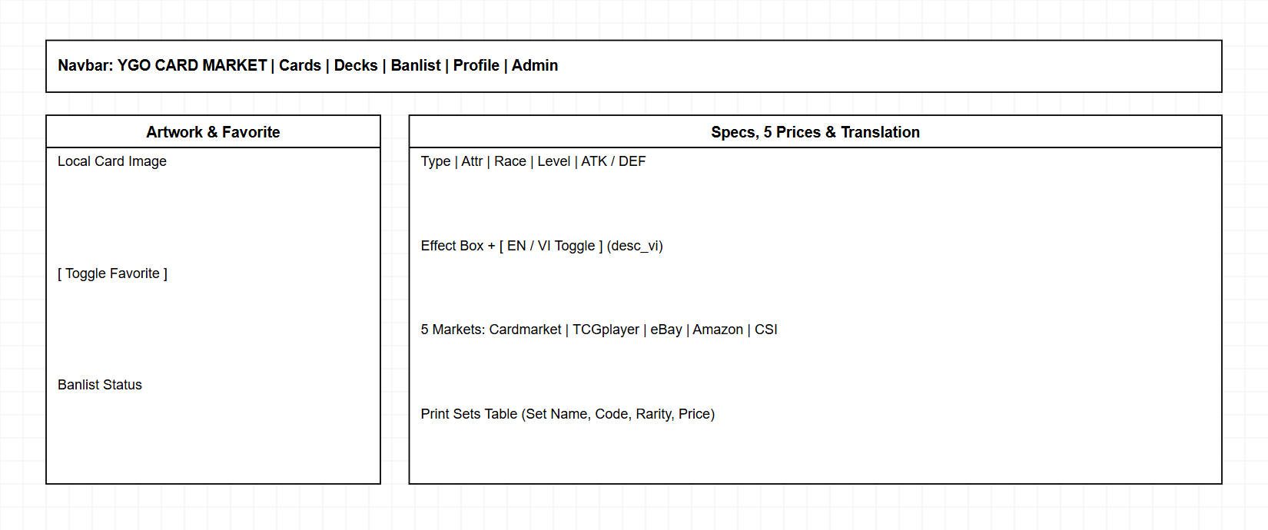
Figure 3.2: CardDetailPage UI Wireframe
Field Name | Description
Card Artwork & Favorite | High-resolution local card artwork paired with Toggle Favorite button (POST /api/auth/favorite/:userId).
Card Effect & Translate | Displays original English effect text (desc) and 'Translate to Vietnamese' action (POST /api/cards/:id/translate).
5-Market Price Bar | Horizontal comparison showing Cardmarket (EUR), TCGplayer (USD), eBay (USD), Amazon (USD), CoolStuffInc (USD), and price_updated_at.
Print Sets Table | Structured table listing Set Name, Set Code, Rarity, and Set Price ($).

3.3 Deck Library, Deck Detail & Personal Deck Builder (DecksPage, DeckDetailPage, DeckBuilderPage)
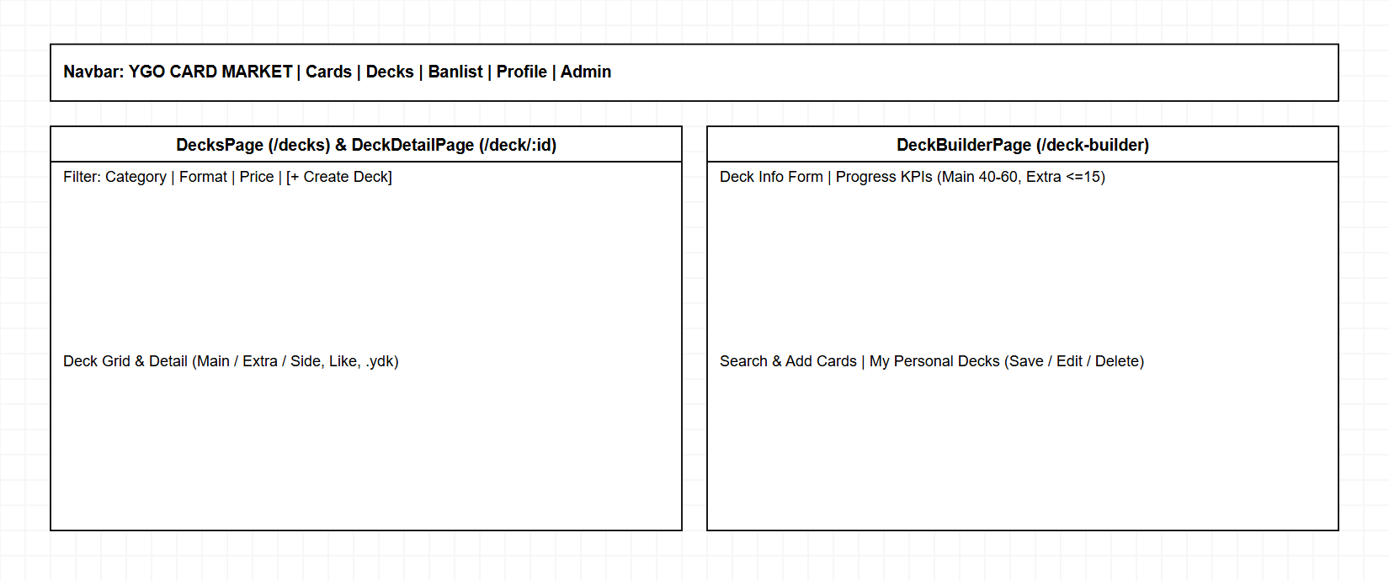
Figure 3.3: DecksPage, DeckDetailPage & DeckBuilderPage UI Wireframe
Field Name | Description
Deck Filter Bar | Filters by Category, Format (TCG/OCG/Master Duel/GOAT/Edison), Archetype, and price range.
Main / Extra / Side Grid | Categorizes cards into Monster/Spell/Trap with copy count badges (1x-3x) and Banlist restriction tags.
Personal Deck Builder | Interactive builder (/deck-builder) with card search, type chips, Main (40-60) / Extra (<=15) / Side (<=15) counters, and My Decks management.
Like & Export .ydk | Buttons to increment deck likes and download a formatted .ydk file.

3.4 Banlist History (BanlistPage)
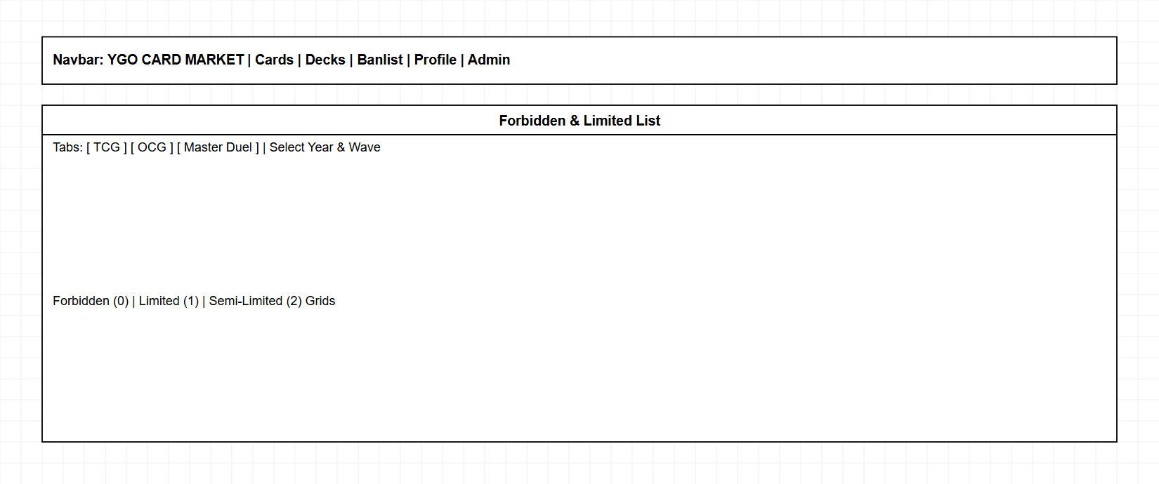
Figure 3.4: BanlistPage UI Wireframe
Field Name | Description
Format Tabs & Select Filters | Switches between TCG / OCG / Master Duel lists, selects Year and effective Month via dropdowns, and filters Forbidden (0), Limited (1), and Semi-Limited (2) cards.

3.5 Authentication & Profile (AuthPage & ProfilePage)
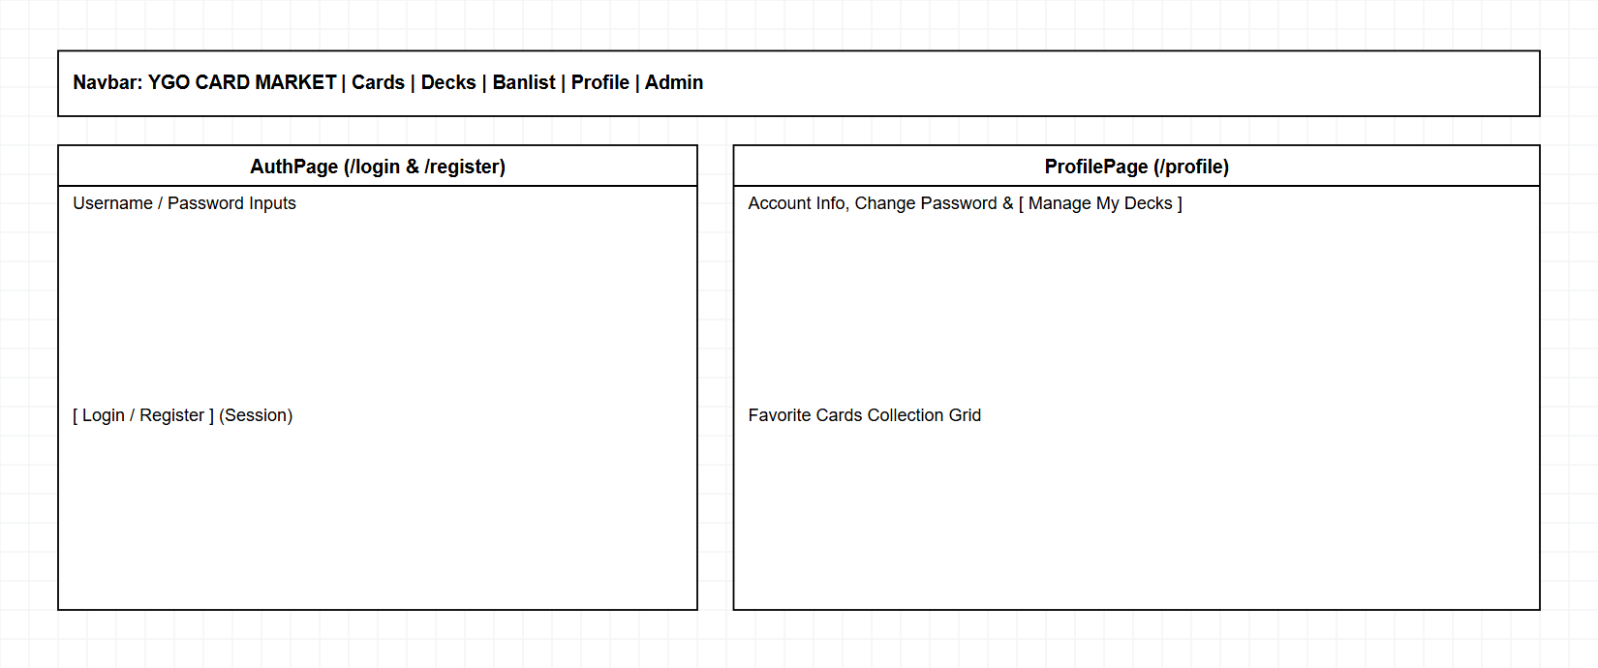
Figure 3.5: AuthPage & ProfilePage UI Wireframe
Field Name | Description
Login / Register Form | Username and password inputs submitting to /api/auth/login or /register.
Profile & Password Form | Displays user info, My Decks shortcut, Favorite Cards grid, and Change Password form.

3.6 Admin Dashboard & CRUD (AdminPage)
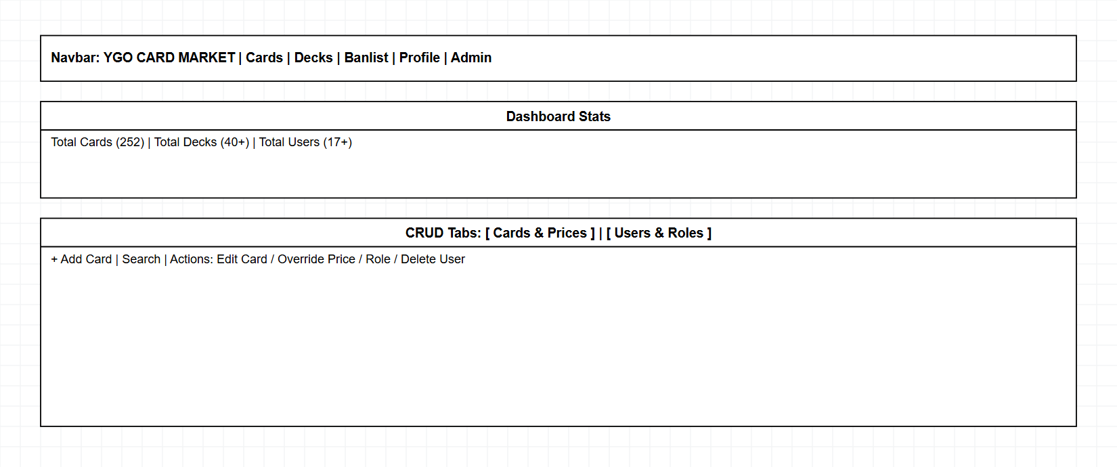
Figure 3.6: AdminPage UI Wireframe
Field Name | Description
Stats Summary Cards | Displays total counts for Meta Cards (252+), Decks (40+), and Users (17+).
Cards & Users Tabs | Management tables supporting Card CRUD operations, 5-Market Price Override, and User Role / Account management.

4. Non-Functional Requirements

4.1 External Interfaces
• User Interfaces: Responsive Dark Mode web UI built with React 18 + Vite to maximize visual contrast for card artwork.
• Software Interfaces: React Router DOM (Frontend), Node.js + Express.js REST API (Backend), MongoDB via Mongoose ODM, and node-cron.
• External Data Interfaces: YGOPRODeck API v7 (https://db.ygoprodeck.com/api/v7/cardinfo.php) accessed strictly via backend sync/cron scripts below 20 req/s.

4.2 Quality Attributes
• Performance: Sub-300ms response time for catalog queries and card lookups using MongoDB indexes (id, name, min_price) and local static images.
• Security: Passwords salted and hashed via crypto.scryptSync with timingSafeEqual verification; strict requireAdmin guard across /api/admin/*.
• Usability & Maintainability: Intuitive EN/VI bilingual translation toggle, one-click .ydk export, and clean SPA/REST API separation.

5. Requirement Appendix

5.1 Business Rules
ID | Rule Definition
BR-01 | Grid prices represent min_price (the lowest available price across 5 tracked markets), accompanied by currency unit (EUR / USD) and price_updated_at.
BR-02 | Link Monsters lack DEF/Level and Spell/Trap cards lack ATK/DEF; the UI must safely handle null/undefined attributes.
BR-03 | All card artwork must be downloaded once and served locally from /images/cards; external hotlinking is prohibited.
BR-04 | Successful Vietnamese translations (desc_vi) are cached permanently in MongoDB to prevent redundant translation calls.
BR-05 | Only authenticated users with role='admin' (verified via requireAdmin middleware) are permitted to access /admin and invoke /api/admin/* endpoints.
BR-06 | Card imagery and game text remain the intellectual property of 4K Media / Konami; the platform operates strictly for non-commercial reference.

